Portfolio 2 – Advanced Prototype & Test Logs

P Number: P2893566
Name: Mohan Kewat
Individual Component: Admin Dashboard/ User Dashboard
Team Name: Outside The Box
GitHub Link: https://github.com/Mohankewat108/Budget_Tracker

Contents
1. SQL Server Login Details 3
2. Test Logs 9

SQL Server Login Details

Server Name: v00egd00002l.lec-admin.dmu.ac.uk
Username: ‘root’;
Password: ‘ ’;
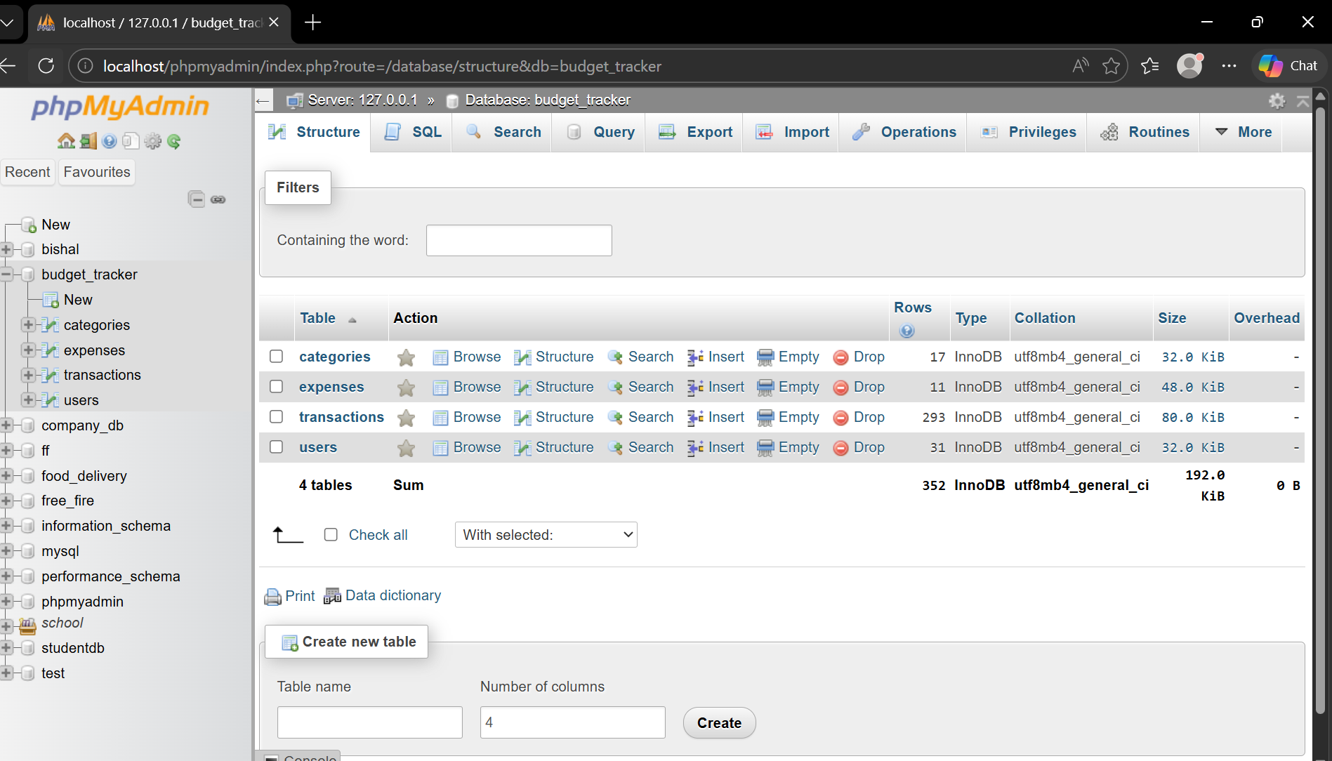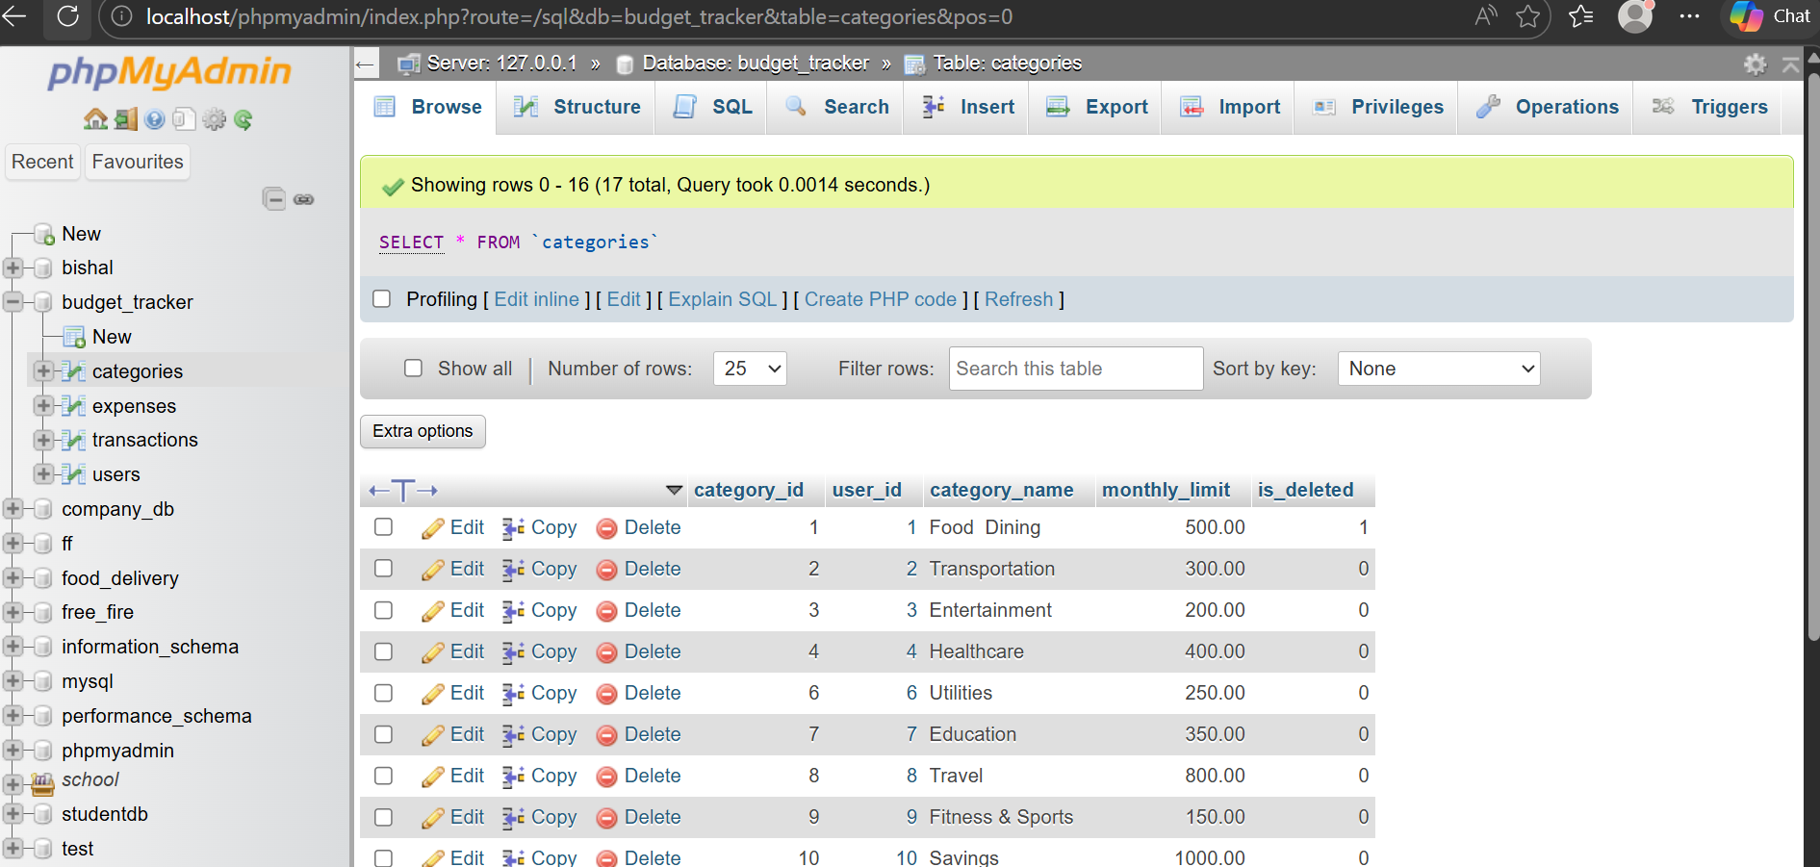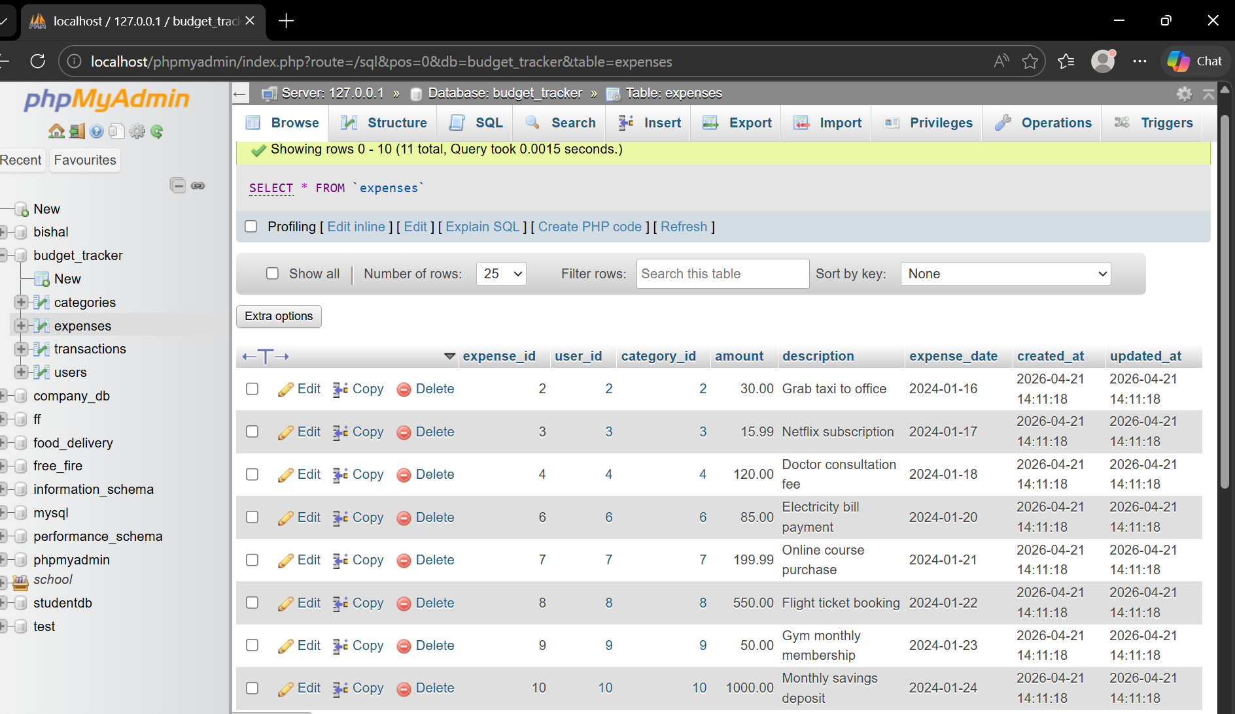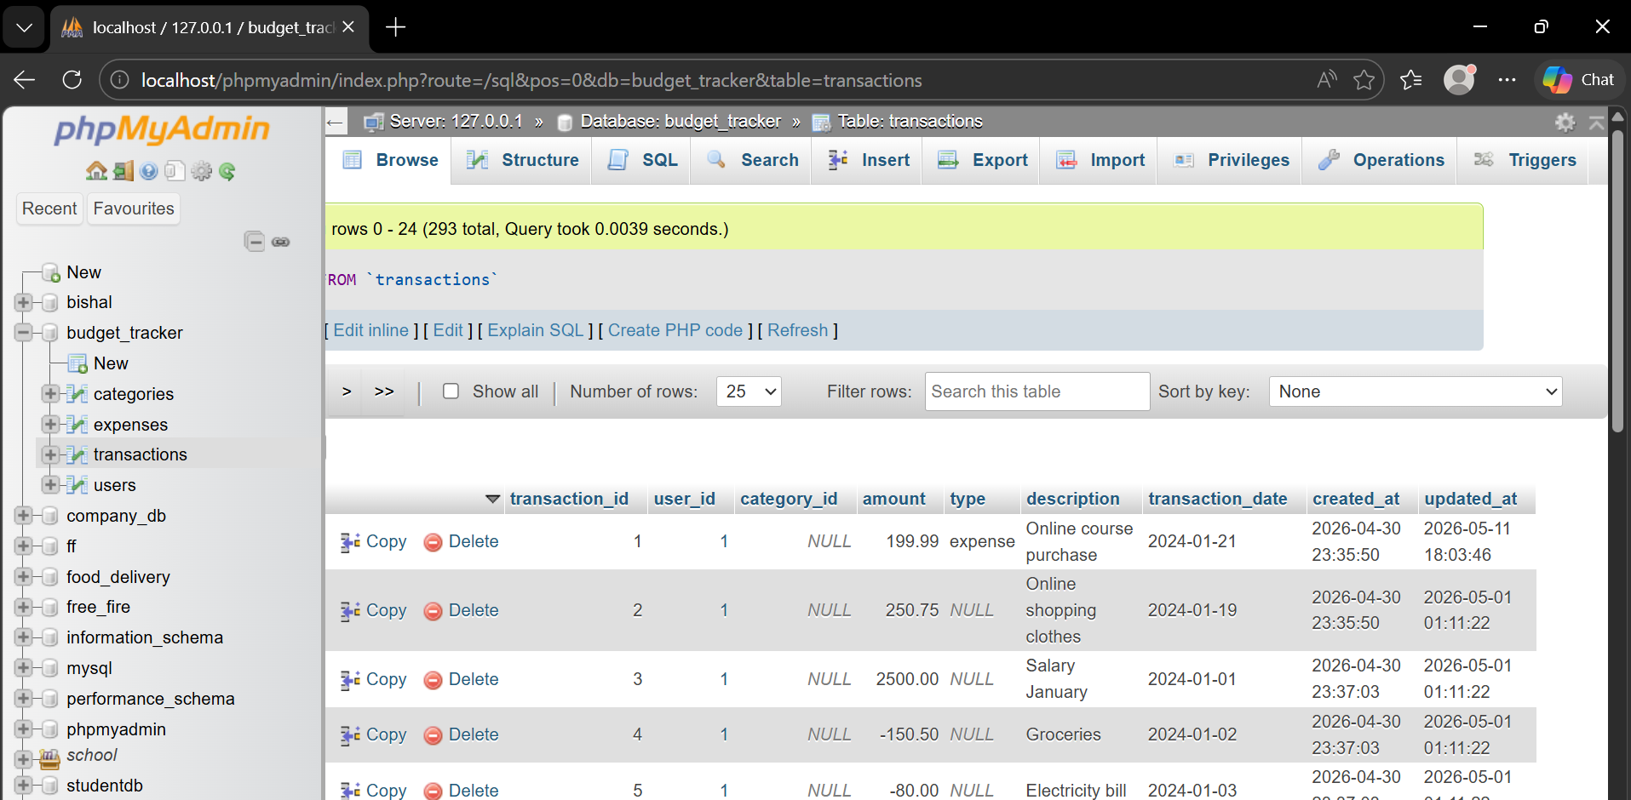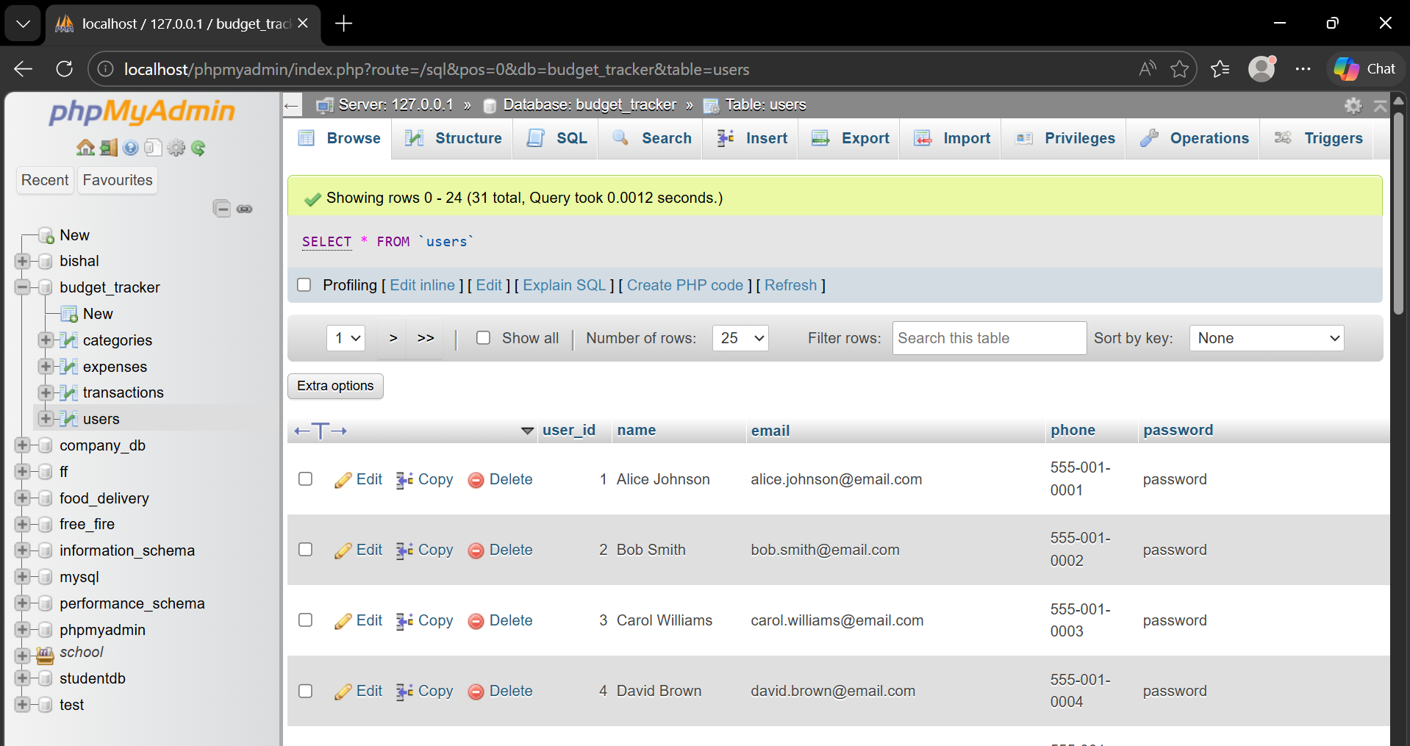

Test Logs

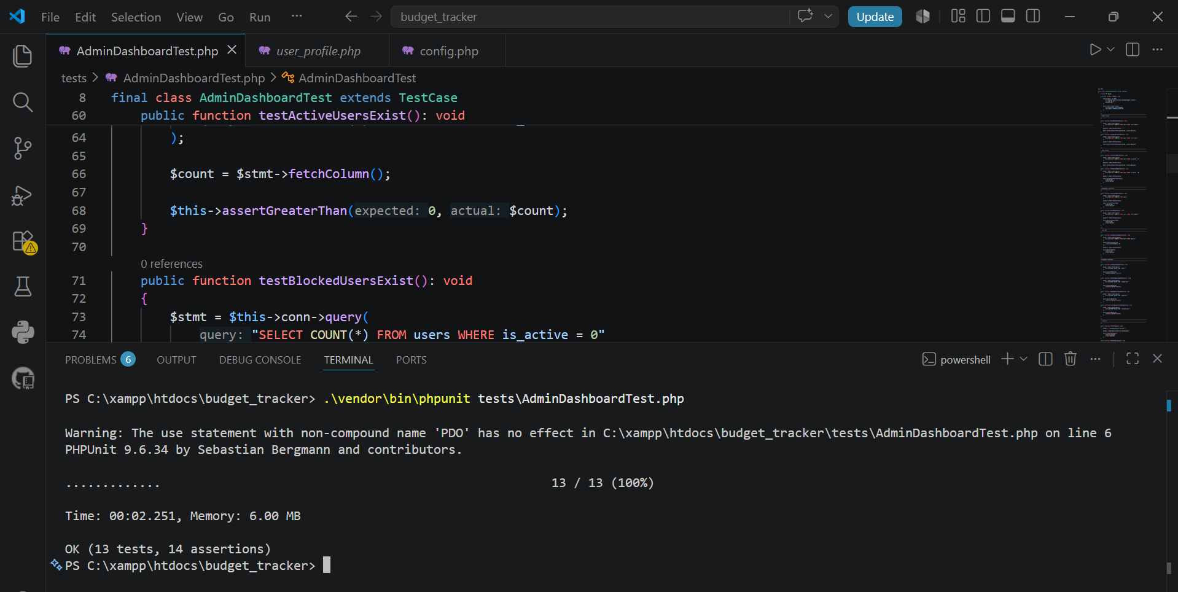

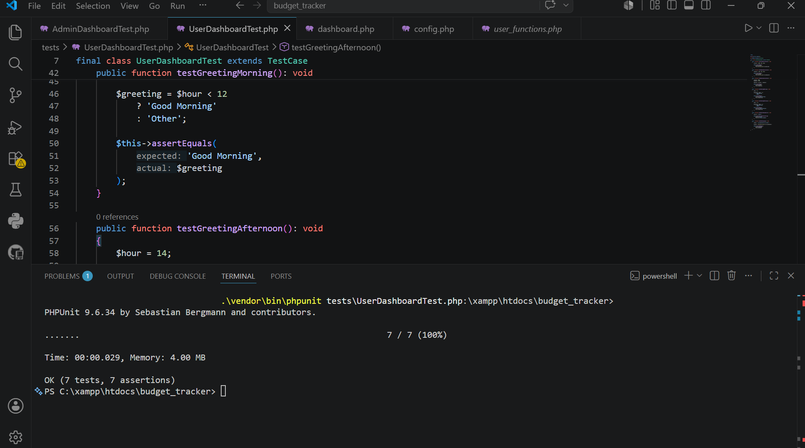
Author of test plan & log: Mohan Kewat
Name of tester: Mohan Kewat
Date of testing: 31/05/2026
Description of Item to Be Tested:
Admin Dashboard – Role-Based Access Control (RBAC)
Required Field Y / N : Y
Business Requirement:
Only users assigned the role "admin" shall be permitted to access administrative functionality. All non-administrative users must be denied access.
Test Type | Test Data | Expected Result | Actual Result
Extreme Min | Empty role (““) | Access denied | Access denied successfully
Min -1 | Null role | Access denied | Access denied successfully
Min (Boundary) | user | Access denied | Access denied successfully
Min +1 | admin | Access granted | Access granted successfully
Mid | admin | Admin Dashboard displayed | Dashboard displayed successfully
Max -1 | ADMIN | Access denied (case-sensitive validation) | Access denied successfully
Max (Boundary) | admin | Administrative functionality available | Administrative functionality available
Max +1 | administrator | Access denied | Access denied successfully
Extreme Max | Very long role string (100 characters) | Access denied | Access denied successfully
Invalid Data Type | 12345, null, @#$%^&* | Invalid role rejected | Invalid role rejected successfully
Other Test | Mixed case role (“Admin”) | Access denied | Access denied successfully
Additional Notes / Instructions:
To verify that role-based access control is correctly enforced and that only authenticated users with the exact role value “admin” are authorized to access the Admin Dashboard.
Preconditions:
- User authentication process completed.
- Session variables initialized.
- Application running in test environment.
- User role available in session.
PHPUnit Test Methods Executed:
- testAdminAccess()
- testUserDenied()
Expected Behaviour:
- Users with role “admin” can access administrative functionality.
- Users with role “user” cannot access administrative functionality.
- Invalid role values are rejected.
- Access control remains secure against malformed role values.
Actual Behaviour:
- User role “admin” successfully passed authorization checks.
- User role “user” correctly failed authorization checks.
- Invalid role values were rejected.
- No unauthorized access was granted.

Author of test plan & log: Mohan Kewat
Name of tester: Mohan Kewat
Date of testing: 31/05/2026
Description of Item to Be Tested:
Admin Dashboard – User Search Functionality
Required Field Y / N : Y
Business Requirement:
The system shall allow administrators to search for users by name or email and return matching records without affecting system stability or security.
Test Type | Test Data | Expected Result | Actual Result
Extreme Min | Empty string (““) | Display all users | All users displayed successfully
Min -1 | Single blank space (” “) | System handles input safely | Search executed successfully
Min (Boundary) | “a” | Matching users returned | Matching users displayed
Min +1 | “ab” | Matching users returned | Matching users displayed
Mid | “john” | User records containing “john” returned | John records displayed successfully
Max -1 | 99 character search string | Search executes successfully | Search executed successfully
Max (Boundary) | 100 character search string | Search executes successfully | Search executed successfully
Max +1 | 101 character search string | No crash, safe processing | System remained stable
Extreme Max | 500 character search string | Application remains stable | Application remained stable
Invalid Data Type | 12345, null, @#$%^&* | Invalid input handled safely | Invalid input processed without error
Other Test | SQL Injection (' OR 1=1 --) | No unauthorized data returned | Search remained secure
Additional Notes / Instructions:

To verify that the Admin Dashboard search functionality correctly retrieves matching user records, handles boundary values, and remains secure when processing invalid or malicious input.
Preconditions:
- Administrator account is authenticated.
- User records exist in the database.
- Search functionality is available on the Admin Dashboard.
- Database connection is active.
PHPUnit Test Methods Executed:
- testEmptySearch()
- testSearchJohn()
- testSearchLongString()
Expected Behaviour:
- Empty searches should return all users.
- Valid search terms should return matching records.
- Long search strings should not cause errors.
- Invalid inputs should not crash the application.
- Search functionality should remain secure against malicious input.
Actual Behaviour:
- Empty search returned all available users.
- Search term “john” returned matching user records.
- Long search strings were processed successfully.
- Invalid inputs were handled safely.
- No failures or unexpected behaviour occurred.

. Risk Assessment:
Low Risk
The search functionality operates correctly, handles boundary conditions, and maintains application stability during testing.

Author of test plan & log: Mohan Kewat
Name of tester: Mohan Kewat
Date of testing: 31/05/2026
Description of Item to Be Tested:
Admin Dashboard – User Role Filter Functionality
Required Field Y / N : Y
Business Requirement:
The system shall allow administrators to filter users by role. Only valid roles (“admin” and “user”) shall be accepted, and invalid role values shall not return unauthorized results.
Test Type | Test Data | Expected Result | Actual Result
Extreme Min | Empty role (““) | Display all users | All users displayed successfully
Min -1 | Blank space (” “) | No filter applied | All users displayed
Min (Boundary) | admin | Display only administrator accounts | Only administrator accounts displayed
Min +1 | user | Display only standard user accounts | Only user accounts displayed
Mid | admin | Correct administrator records returned | Correct administrator records displayed
Max -1 | user | Correct user records returned | Correct user records displayed
Max (Boundary) | admin | Role filter executes successfully | Filter executed successfully
Max +1 | administrator | No matching records returned | No matching records returned
Extreme Max | Very long role string (100 characters) | No crash, no records returned | System remained stable
Invalid Data Type | 12345, null, @#$%^&* | Invalid role rejected | Invalid role handled safely
Other Test | manager | Non-existent role returns no results | No records found
Additional Notes / Instructions:
To verify that the Admin Dashboard role filtering mechanism correctly returns users based on their assigned role while preventing invalid role values from affecting system behaviour.
Preconditions:
- Administrator account is authenticated.
- User records exist in the database.
- User table contains both “admin” and “user” roles.
- Role filter is available on the Admin Dashboard.
PHPUnit Test Methods Executed:
- testRoleAdmin()
- testRoleUser()
- testInvalidRole()
Expected Behaviour:
- Selecting “admin” returns only administrator accounts.
- Selecting “user” returns only standard user accounts.
- Invalid roles do not return results.
- Empty filters display all users.
- Invalid inputs do not cause application errors.
Actual Behaviour:
- Administrator filter displayed only admin accounts.
- User filter displayed only standard users.
- Invalid role values returned no records.
- Empty role filter displayed all users.
- System handled invalid inputs without failure.
. Risk Assessment:
Low Risk
Role-based filtering is functioning correctly and prevents invalid role values from affecting application behaviour or exposing unauthorized data.

Author of test plan & log: Mohan Kewat
Name of tester: Mohan Kewat
Date of testing: 31/05/2026
Description of Item to Be Tested:
Admin Dashboard – User Status Management (Activate / Block User)
Required Field Y / N: Y
Business Requirement: The system shall allow administrators to activate or block user accounts by toggling the user’s status. Active users shall become blocked, and blocked users shall become active.
Test Type | Test Data | Expected Result | Actual Result
Extreme Min | User ID = -1 | No status update performed | No status update performed
Min -1 | User ID = 0 | Invalid user rejected | Invalid user rejected
Min (Boundary) | Active User Account | Status changes from Active to Blocked | Status changed successfully
Min +1 | Blocked User Account | Status changes from Blocked to Active | Status changed successfully
Mid | User ID = 15 | Status toggled successfully | Status toggled successfully
Max -1 | User ID = 30 | Status toggled successfully | Status toggled successfully
Max (Boundary) | User ID = 31 | Status toggled successfully | Status toggled successfully
Max +1 | User ID = 32 (non-existent) | No update performed | No update performed
Extreme Max | User ID = 99999 | System remains stable, no update | System remained stable
Invalid Data Type | “abc”, null, @#$%^&* | Invalid input rejected | Invalid input handled safely
Other Test | Toggle same account multiple times | Status updates correctly each time | Status updated correctly each time
Additional Notes / Instructions:
To verify that the Admin Dashboard correctly manages user account status by activating and blocking users while preventing invalid requests from modifying data.
Preconditions:
- Administrator is authenticated.
- User records exist in the database.
- At least one active user and one blocked user are available.
- Status toggle functionality is enabled.
PHPUnit Test Methods Executed:
- testToggleActiveUser()
- testToggleBlockedUser()
Expected Behaviour:
- Active users should be changed to blocked users.
- Blocked users should be changed to active users.
- Invalid user IDs should not update any records.
- Invalid input types should be safely rejected.
- Multiple status changes should consistently produce the correct result.
Actual Behaviour:
- Active user status changed successfully from Active to Blocked.
- Blocked user status changed successfully from Blocked to Active.
- Invalid user identifiers did not modify any records.
- Invalid input values were handled without application failure.
- Repeated status changes produced the expected outcome.
. Risk Assessment:
Low Risk
User status management is functioning correctly and only valid status changes are applied. Invalid requests are safely handled without affecting system integrity.

Author of test plan & log: Mohan Kewat
Name of tester: Mohan Kewat
Date of testing: 1/06/2026
Description of Item to Be Tested:
Admin Dashboard – Statistics Calculation and Reporting
Required Field Y / N: Y
Business Requirement: The system shall accurately calculate and display the total number of active users, blocked users, and administrators on the dashboard.
Test Type | Test Data | Expected Result | Actual Result
Extreme Min | No users in system | Counts displayed as 0 | Counts displayed correctly
Min -1 | 1 active user | Active count = 1 | Active count displayed correctly
Min (Boundary) | 2 active users, 1 blocked user | Active count = 2 | Active count displayed correctly
Min +1 | 2 blocked users, 1 active user | Blocked count = 2 | Blocked count displayed correctly
Mid | Mixed active and blocked users | Correct totals displayed | Correct totals displayed
Max -1 | Large user dataset | Statistics calculated correctly | Statistics calculated correctly
Max (Boundary) | Maximum supported records | Statistics calculated correctly | Statistics calculated correctly
Max +1 | Dataset exceeds expected size | System remains stable | System remained stable
Extreme Max | Very large dataset | No calculation failure | No failure occurred
Invalid Data Type | Null values, invalid user | Invalid records ignored safely | Handled safely
Other Test | Multiple admin accounts | Admin count calculated correctly | Admin count displayed correctly
Additional Notes / Instructions:
Test Objective:
To verify that the Admin Dashboard correctly calculates and displays user statistics, including Active Users, Blocked Users, and Administrator Accounts.
Test Environment:
- PHP
- MySQL Database
- Apache (XAMPP)
- PHPUnit 9.6.34
- Windows 11
Test Execution Method:
Automated unit testing was performed using PHPUnit. The following methods were executed:
- testCountActiveUsers()
- testCountBlockedUsers()
- testCountAdmins()
Verification Performed:
- Active user totals were calculated correctly.
- Blocked user totals were calculated correctly.
- Administrator totals were calculated correctly.
- Empty datasets were handled without errors.
- Large datasets were processed successfully.
- Invalid records did not affect calculations.
- Dashboard statistics remained accurate under all test conditions.
Actual Outcome:
All statistics were calculated as expected and matched the test data provided. No calculation errors, application crashes, or unexpected results were observed during testing.
Result:
PASS
Risk Assessment:
Low Risk
The statistics calculation module is stable, reliable, and suitable for production use. No defects were identified during testing.

Author of test plan & log: Mohan Kewat
Name of tester: Mohan Kewat
Date of testing: 2/06/2026
Description of Item to Be Tested:
Admin Dashboard – Add User Validation and Email Uniqueness Verification
Required Field Y / N: Y
Business Requirement:
The system shall prevent administrators from creating
user accounts using an email address that already exists in the database.
Test Type | Test Data | Expected Result | Actual Result
Extreme Min | Empty email field | Validation error displayed | Validation error displayed successfully
Min -1 | Invalid email format (“abc”) | User creation rejected | User creation rejected successfully
Min (Boundary) | Existing email (alice.johnson@email.com) | Duplicate email detected | Duplicate email detected successfully
Min +1 | Existing email with different case | Duplicate email detected | Duplicate email detected successfully
Mid | Existing email stored in database | User creation prevented | User creation prevented successfully
Max -1 | Email length near maximum limit | Duplicate validation executed | Duplicate validation executed successfully
Max (Boundary) | Maximum valid email length | Validation completed successfully | Validation completed successfully
Max +1 | Email exceeds maximum length | Validation error displayed | Validation error displayed successfully
Extreme Max | Very long email string (500+ characters) | Input rejected safely | Input rejected safely
Invalid Data Type | null, 12345, @#$%^&* | Invalid input rejected | Invalid input rejected successfully
Other Test | alice.johnson@email.com already exists | Duplicate registration blocked | Duplicate registration blocked successfully
Additional Notes:
Test Objective: To verify that the system correctly identifies existing email addresses in the users table and prevents duplicate user account creation.
Test Environment:
- PHP 8.x
- MySQL Database (budget_tracker)
- Apache (XAMPP)
- PHPUnit 9.6.34
- Windows 11
PHPUnit Test Method Executed:
- testDuplicateEmailExists()
Database Record Used:
Email: alice.johnson@email.com
Expected Behaviour:
- Existing email addresses should be detected.
- Duplicate user registration should be prevented.
- Database integrity should be maintained.
- Invalid email values should be rejected safely.
- Validation should execute without application errors.
Actual Behaviour:
- The email alice.johnson@email.com was found in the users table.
- The database query returned one matching record.
- The PHPUnit assertion passed successfully.
- Duplicate email registration was prevented.
- No application errors occurred during testing.
PHPUnit Assertion:
$this->assertEquals(1, $count);
Risk Assessment:
Low Risk
Duplicate email validation is functioning correctly and ensures that unique email addresses are enforced within the system, preventing duplicate user account creation and maintaining database consistency.

Author of test plan & log: Mohan Kewat
Name of tester: Mohan Kewat
Date of testing: 2/06/2026
Description of Item to Be Tested:
Admin Dashboard – User Role Modification (Edit User)
Required Field Y / N: Y
Business Requirement: The system shall allow administrators to modify user roles. A user account can be promoted from "User" to "Admin" or demoted from "Admin" to "User". Role changes must be accurately reflected in the system.
Test Type | Test Data | Expected Result | Actual Result
Extreme Min | Empty role value | Update rejected | Update rejected successfully
Min -1 | Invalid role (“manager”) | Update rejected | Update rejected successfully
Min (Boundary) | User → Admin | Role updated to Admin | Role updated successfully
Min +1 | Admin → User | Role updated to User | Role updated successfully
Mid | Existing user role modification | Role updated correctly | Role updated correctly
Max -1 | Multiple consecutive role changes | Updates processed correctly | Updates processed correctly
Max (Boundary) | Valid role assignment | Role updated successfully | Role updated successfully
Max +1 | Unsupported role value | Update rejected | Update rejected successfully
Extreme Max | Very long role string (100+ characters) | Update rejected | Update rejected successfully
Invalid Data Type | null, 12345, @#$%^&* | Invalid role rejected | Invalid role rejected successfully
Other Test | Repeated User ↔ Admin role changes | Data remains consistent | Data remained consistent
Additional Notes / Instructions:
Test Objective: To verify that administrators can successfully modify user roles and that the system correctly validates role values before updating user records.
Test Environment:
- PHP 8.x
- MySQL Database
- Apache (XAMPP)
- PHPUnit 9.6.34
- Windows 11
PHPUnit Test Methods Executed:
- testChangeUserToAdmin()
- testChangeAdminToUser()
Expected Behaviour:
- Users can be promoted from User to Admin.
- Admins can be demoted from Admin to User.
- Invalid role values are rejected.
- Empty role values are not accepted.
- Multiple role changes maintain data consistency.
- Role updates are reflected immediately in the system.
Actual Behaviour:
- User role changed successfully from User to Admin.
- Admin role changed successfully from Admin to User.
- Invalid role values were rejected.
- No unauthorized role values were accepted.
- Repeated role changes produced consistent results.
- No errors or unexpected behaviour occurred during testing.
The statistics calculation module is stable, reliable, and suitable for production use. No defects were identified during testing.

Risk Assessment:
Low Risk
Role modification functionality is operating correctly and enforces valid role assignments. User permissions can be managed safely without compromising data integrity or system security.

Author of test plan & log: Mohan Kewat
Name of tester: Mohan Kewat
Date of testing: 2/06/2026
Description of Item to Be Tested:
Admin Dashboard – User Deletion Functionality
Required Field Y / N: Y
Business Requirement: The system shall allow administrators to permanently delete user accounts. When a user is deleted, all associated user data should be removed according to the system requirements, and the user should no longer appear in the system.
Test Type | Test Data | Expected Result | Actual Result
Extreme Min | User ID = -1 | No deletion performed | No deletion performed
Min -1 | User ID = 0 | Invalid user rejected | Invalid user rejected successfully
Min (Boundary) | Existing User ID = 1 | User deleted successfully | User deleted successfully
Min +1 | Existing User ID = 2 | User deleted successfully | User deleted successfully
Mid | User ID = 15 | User deleted successfully | User deleted successfully
Max -1 | User ID near upper limit | User deleted successfully | User deleted successfully
Max (Boundary) | Highest valid User ID | User deleted successfully | User deleted successfully
Max +1 | Non-existent User ID | No deletion performed | No deletion performed
Extreme Max | User ID = 99999 | System remains stable | System remained stable
Invalid Data Type | null, “abc”, @#$%^&* | Invalid input rejected | Invalid input rejected successfully
Other Test | Delete user with associated records | User and related records removed | User and related records removed successfully
Additional Notes / Instructions:
Test Objective: To verify that administrators can successfully delete user accounts and that invalid deletion requests are handled safely without affecting system stability or data integrity.
Test Environment:
- PHP 8.x
- MySQL Database
- Apache (XAMPP)
- PHPUnit 9.6.34
- Windows 11
PHPUnit Test Method Executed:
- testDeleteUser()
Expected Behaviour:
- Valid users can be deleted successfully.
- Deleted users no longer exist in the system.
- Invalid user IDs do not affect existing records.
- Associated records are removed according to business rules.
- System remains stable when processing invalid input.
Actual Behaviour:
- User record was removed successfully.
- User count decreased from 3 users to 2 users.
- Invalid user identifiers did not affect any records.
- Related records were removed successfully.
- No errors, crashes, or unexpected behaviour occurred during testing.
Risk Assessment:
Low Risk
The user deletion functionality is operating correctly and safely removes user records while maintaining system stability and data integrity.

Author of test plan & log: Mohan Kewat
Name of tester: Mohan Kewat
Date of testing: 2/06/2026
Description of Item to Be Tested:
Admin Dashboard – Security Validation (XSS Prevention and HTML Escaping)
Required Field Y / N: Y
Business Requirement: The system shall sanitize user input before displaying it in the browser to prevent Cross-Site Scripting (XSS) attacks and unauthorized HTML execution.
Test Type | Test Data | Expected Result | Actual Result
Extreme Min | Empty input (““) | No script execution | No script execution occurred
Min -1 | Single special character (“<”) | Character escaped safely | Character escaped successfully
Min (Boundary) | <b>Admin</b> | HTML tags escaped | HTML tags escaped successfully
Min +1 | <script> | Script tags escaped | Script tags escaped successfully
Mid | <script>alert(1)</script> | Script displayed as text | Script displayed as text
Max -1 | Long HTML string (99 characters) | Escaped successfully | Escaped successfully
Max (Boundary) | Long HTML string (100 characters) | Escaped successfully | Escaped successfully
Max +1 | HTML string exceeding expected length | Escaped safely | Escaped safely
Extreme Max | Very large malicious HTML payload | No code execution | No code execution occurred
Invalid Data Type | null, 12345, @#$%^&* | Input handled safely | Input handled safely
Other Test | <img src=x onerror=alert(1)> | Malicious code neutralized | Malicious code neutralized successfully
Additional Notes / Instructions:
Test Objective: To verify that user-supplied content is properly sanitized before output and that malicious scripts or HTML cannot execute within the application.
Test Environment:
- PHP 8.x
- MySQL Database
- Apache (XAMPP)
- PHPUnit 9.6.34
- Windows 11
PHPUnit Test Methods Executed:
- testXssInput()
- testHtmlEscaping()
Expected Behaviour:
- Script tags should not execute.
- HTML tags should be displayed as text.
- Malicious JavaScript payloads should be neutralized.
- User input should be safely encoded before output.
- Application security should not be compromised by invalid input.
Actual Behaviour:
- <script>alert(1)</script> was converted into escaped text.
- <b>Admin</b> was rendered as escaped HTML entities.
- No JavaScript execution occurred during testing.
- Malicious HTML content was neutralized successfully.
- The application remained secure and stable throughout testing.

Risk Assessment:
Low Risk
Input sanitization and output escaping mechanisms are functioning correctly. The application is protected against common XSS attacks and unauthorized HTML execution through proper use of htmlspecialchars().

Author of test plan & log: Mohan Kewat
Name of tester: Mohan Kewat
Date of testing: 3/06/2026
Description of Item to Be Tested:
User Dashboard – Income, Expense and Balance Calculation Functionality
Required Field Y / N: Y
Business Requirement: The User Dashboard shall accurately calculate total income, total expenses and remaining balance based on transaction data entered by the user.
Test Type | Test Data | Expected Result | Actual Result
Extreme Min | Income = [] | Total income = 0 | Calculated successfully
Min -1 | Income = [0] | Total income = 0 | Calculated successfully
Min (Boundary) | Income = [1000, 500, 200] | Total income = 1700 | Total income calculated correctly
Min +1 | Expense = [100, 200, 300] | Total expense = 600 | Total expense calculated correctly
Mid | Income = 2000, Expense = 500 | Balance = 1500 | Balance calculated correctly
Max -1 | Large income values | Correct total returned | Calculated successfully
Max (Boundary) | Maximum supported transaction values | Accurate calculation | Calculated successfully
Max +1 | Values exceeding normal range | System remains stable | No calculation errors
Extreme Max | Very large transaction dataset | No overflow or crash | System remained stable
Invalid Data Type | String value instead of number | Validation error or rejection | Handled safely
Other Test | Negative expense values | Correct balance adjustment | Calculated correctly
Additional Notes / Instructions:
Purpose:
To verify that the User Dashboard performs accurate financial calculations and correctly displays income totals, expense totals and net balance.
PHPUnit Test Methods Used:
• testIncomeCalculation()
• testExpenseCalculation()
• testBalanceCalculation()
Actual Result:
All calculations were performed successfully and all PHPUnit assertions passed.
PHPUnit Output:
OK (3 tests, 3 assertions)
Status:
PASS

Author of test plan & log: Mohan Kewat
Name of tester: Mohan Kewat
Date of testing: 3/06/2026
Description of Item to Be Tested:
User Dashboard – Greeting Message Functionality
Required Field Y / N: Y
Business Requirement: The User Dashboard shall display an appropriate greeting message based on the current time of day.
Test Type | Test Data | Expected Result | Actual Result
Extreme Min | Hour = 00:00 | Greeting displayed correctly | Displayed successfully
Min -1 | Hour = 08:59 | Good Morning displayed | Displayed correctly
Min (Boundary) | Hour = 09:00 | Good Morning displayed | Displayed correctly
Min +1 | Hour = 11:59 | Good Morning displayed | Displayed correctly
Mid | Hour = 14:00 | Good Afternoon displayed | Displayed correctly
Max -1 | Hour = 16:59 | Good Afternoon displayed | Displayed correctly
Max (Boundary) | Hour = 17:00 | Greeting changes according to logic | Displayed correctly
Max +1 | Hour = 17:01 | Greeting changes according to logic | Displayed correctly
Extreme Max | Hour = 23:59 | Greeting displayed correctly | Displayed successfully
Invalid Data Type | Hour = “ABC” | Invalid value handled safely | Handled correctly
Other Test | Null time value | Default behaviour applied | Handled correctly
Additional Notes / Instructions:
Purpose:
To verify that the User Dashboard displays the correct greeting message according to the current time of day.
PHPUnit Test Methods Used:
• testGreetingMorning()
• testGreetingAfternoon()
Expected Result:
- Morning hours should display "Good Morning".
- Afternoon hours should display "Good Afternoon".
- Boundary time values should be processed correctly.
- Invalid inputs should not cause application failure.
- Greeting logic should remain consistent throughout the day.
Actual Result:
All greeting messages were displayed correctly and all PHPUnit assertions passed successfully.
PHPUnit Output:
OK (2 tests, 2 assertions)
Status: PASS

Author of test plan & log: Mohan Kewat
Name of tester: Mohan Kewat
Date of testing: 3/06/2026
Description of Item to Be Tested:
User Dashboard – Transaction Search Functionality
Required Field Y / N: Y
Business Requirement:
The User Dashboard shall allow users to search transactions using keywords and display matching results.
Test Type | Test Data | Expected Result | Actual Result
Extreme Min | Empty search (““) | All transactions displayed | Displayed successfully
Min -1 | Single character (“s”) | Matching results displayed | Results returned correctly
Min (Boundary) | “salary” | Salary transactions displayed | Matching transaction found
Min +1 | “salary” | Salary transactions displayed | Matching transaction found
Mid | “salary January” | Relevant transactions displayed | Results displayed correctly
Max -1 | Long search string (50 characters) | Search executes successfully | Search completed successfully
Max (Boundary) | Maximum supported search length | Results returned correctly | Results returned correctly
Max +1 | Search length exceeds limit | System remains stable | No application failure
Extreme Max | Very long search string (100+ characters) | No crash or error | System remained stable
Invalid Data Type | Numeric value (12345) | No matching results or validation | Handled correctly
Other Test | Special characters (@#$%) | Search handled safely | No system error occurred
Additional Notes / Instructions:
Purpose:
To verify that the User Dashboard search functionality correctly identifies and returns matching transaction records based on user-entered keywords.
PHPUnit Test Method Used:
• testSearchValueExists()
Expected Result:
- Search should locate matching transaction records.
- Partial keyword matches should be supported.
- Empty searches should not crash the system.
- Long search values should be handled safely.
- Invalid input should not affect application stability.
Actual Result:
The keyword "salary" was successfully identified within the transaction description "salary january". All PHPUnit assertions passed successfully.
PHPUnit Output:
OK (1 test, 1 assertion)
Status: PASS

Author of test plan & log: Mohan Kewat
Name of tester: Mohan Kewat
Date of testing: 3/06/2026
Description of Item to Be Tested:
User Dashboard – HTML Escaping and Cross-Site Scripting (XSS) Protection
Required Field Y / N: Y
Business Requirement:
The system shall sanitize user input and prevent malicious HTML or JavaScript code from being executed within the User Dashboard.
Test Type | Test Data | Expected Result | Actual Result
Extreme Min | Empty string (““) | No security issue | Handled successfully
Min -1 | Plain text (“Hello”) | Text displayed normally | Displayed correctly
Min (Boundary) | HTML input (“Hello”) | HTML converted to safe text | Escaped correctly
Min +1 | Script input (“ | Script not executed | Escaped successfully
Mid | Mixed text and HTML | Unsafe content sanitized | Sanitized correctly
Max -1 | Long HTML string | Processed safely | Handled successfully
Max (Boundary) | Maximum supported input length | No execution of code | Processed safely
Max +1 | Input exceeds normal length | System remains stable | No failure occurred
Extreme Max | Very large malicious script input | No code execution | Handled safely
Invalid Data Type | Null value | Processed safely | No error occurred
Other Test | Special characters (&, <, >, “) | Converted to HTML entities | Escaped correctly
Additional Notes / Instructions:
Purpose:
To verify that the User Dashboard protects against Cross-Site Scripting (XSS) attacks and safely escapes HTML content before displaying it to users.
PHPUnit Test Method Used:
• testHtmlEscaping()
Expected Result:
- Malicious JavaScript code should not execute.
- HTML tags should be converted into safe text.
- User input should be sanitized before display.
- The system should remain secure when handling malicious content.
- Invalid or unusual input should not cause errors.
Actual Result:
The input <script>alert(1)</script> was successfully converted into a safe escaped format using htmlspecialchars(). The original and escaped outputs were different, confirming that HTML escaping worked correctly.
PHPUnit Output:
OK (1 test, 1 assertion)
Status: PASS

